Task 1

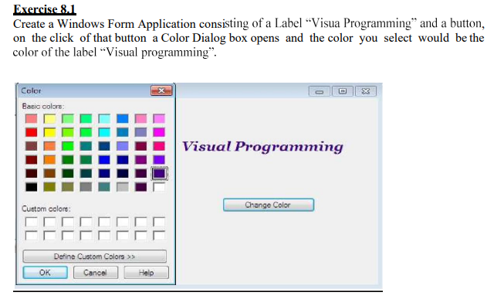

Code

using System;

using System.Collections.Generic;

using System.ComponentModel;

using System.Data;

using System.Drawing;

using System.Linq;

using System.Text;

using System.Threading.Tasks;

using System.Windows.Forms;

namespace WindowsFormsApp34

{

public partial class Form1 : Form

{

public Form1()

{

InitializeComponent();

}

private void button1_Click(object sender, EventArgs e)

{

ColorDialog colorDlg = new ColorDialog();

colorDlg.AnyColor = true;

colorDlg.SolidColorOnly = false;

if (colorDlg.ShowDialog() == DialogResult.OK)

{

label1.ForeColor = colorDlg.Color;

}

}

}

}

Output

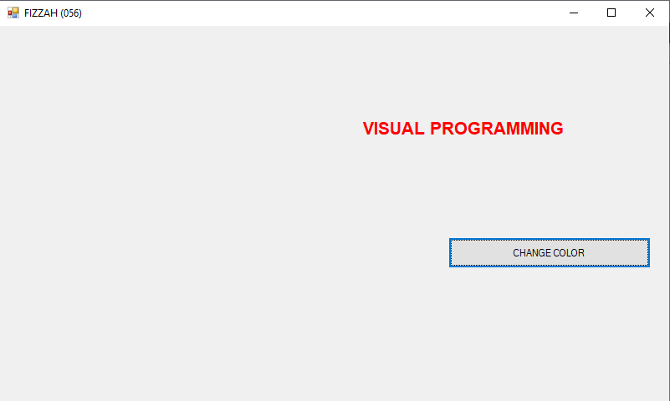

Task 2

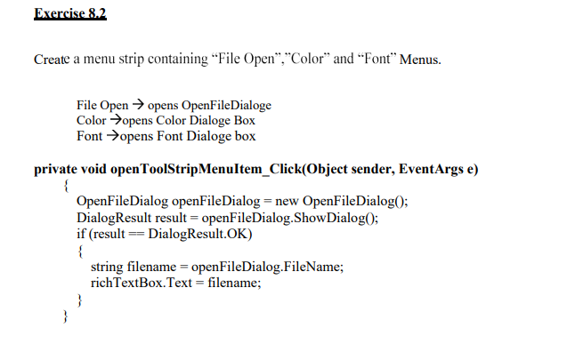

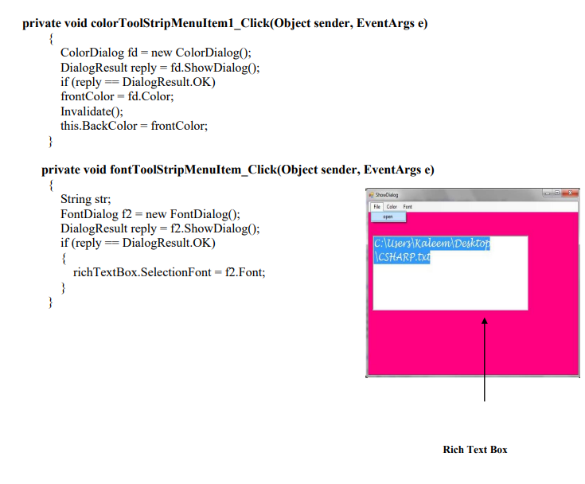

Code

using System;

using System.Collections.Generic;

using System.ComponentModel;

using System.Data;

using System.Drawing;

using System.Linq;

using System.Text;

using System.Threading.Tasks;

using System.Windows.Forms;

namespace WindowsFormsApp33

{

public partial class Form1 : Form

{

private Color frontColor;

public Form1()

{

InitializeComponent();

}

private void fILEToolStripMenuItem_Click(object sender, EventArgs e)

{

OpenFileDialog openFileDialog = new OpenFileDialog();

DialogResult result = openFileDialog.ShowDialog();

if (result == DialogResult.OK)

{

string filename = openFileDialog.FileName;

richTextBox1.Text = filename;

}

}

private void cOLORToolStripMenuItem_Click(object sender, EventArgs e)

{

ColorDialog fd = new ColorDialog();

DialogResult reply = fd.ShowDialog();

if (reply == DialogResult.OK)

frontColor = fd.Color;

Invalidate();

this.BackColor = frontColor;

}

private void fONTToolStripMenuItem_Click(object sender, EventArgs e)

{

String str;

FontDialog f2 = new FontDialog();

DialogResult reply = f2.ShowDialog();

if (reply == DialogResult.OK)

{

richTextBox1.SelectionFont = f2.Font;

}

}

}

}

Output

